**Microsoft Project 2016: Tutorial 4**

**Critical path analysis**

**1. Getting started**

Start MS Project and open a new blank project.

We’re going to prepare a project plan for putting together a research grant application.

Set the project start date to 20th March 2017.

Add the following tasks, durations and dependencies to the project:

|  |  |  |  |
| --- | --- | --- | --- |
| **Task Id** | **Task name** | **Duration** | **Predecessor** |
| 1 | Planning meeting | 1 day |  |
| 2 | Project costing | 3 days | 1 |
| 3 | Write draft application | 10 days | 1 |
| 4 | Create USW EFAS A | 1 day | 1 |
| 5 | Progress meeting | 1 day | 2, 3, 4 |
| 6 | Write final application | 20 days | 5 |
| 7 | Create USW EFAS B | 3 days | 5 |
| 8 | Submit application | 1 day | 6, 7 |

Make sure all tasks are in Auto Schedule mode. This should result in:

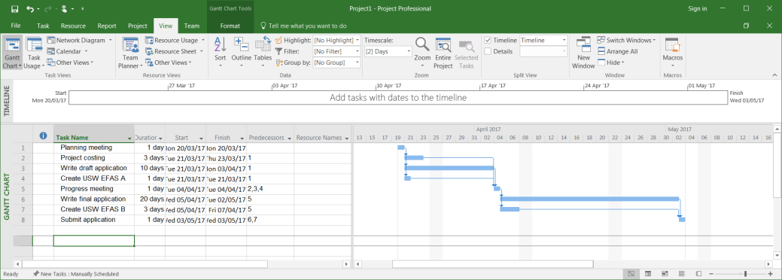

Make sure the project is saved – give it the name “GrantApplication”.

**2. Viewing the critical path**

You hopefully realise by now that MS Project automatically creates and maintains a project Gantt Chart as tasks, durations and dependencies are added to the project (and subsequently edited).

MS Project is also able to calculate and display the critical path through a project, along with associated information such Earliest Start, Latest Start, Earliest Finish, Latest Finish and Float values for the various tasks.

The critical path can be displayed in a variety of ways. To view the critical path using the Gantt chart, select the Format tab and tick Critical Tasks option box. The critical path will be displayed in red in the Gantt chart:

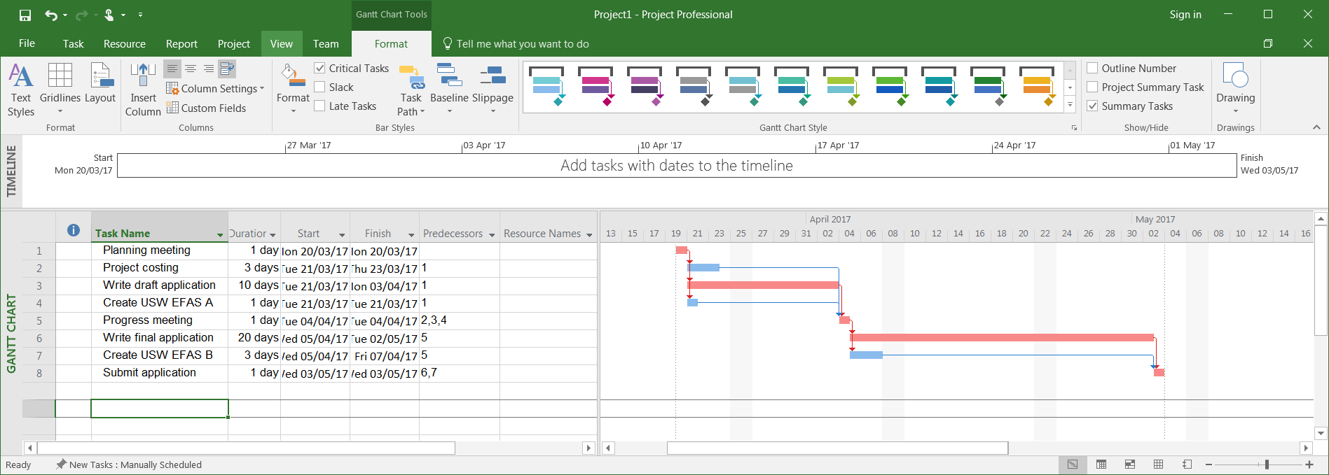

The float on each activity can be displayed by ticking the Slack option box (MS Project uses the term Slack for Float). The slack in an activity is represented in the Gantt chart by a single black line originating from the base of that activity’s Gantt chart bar:

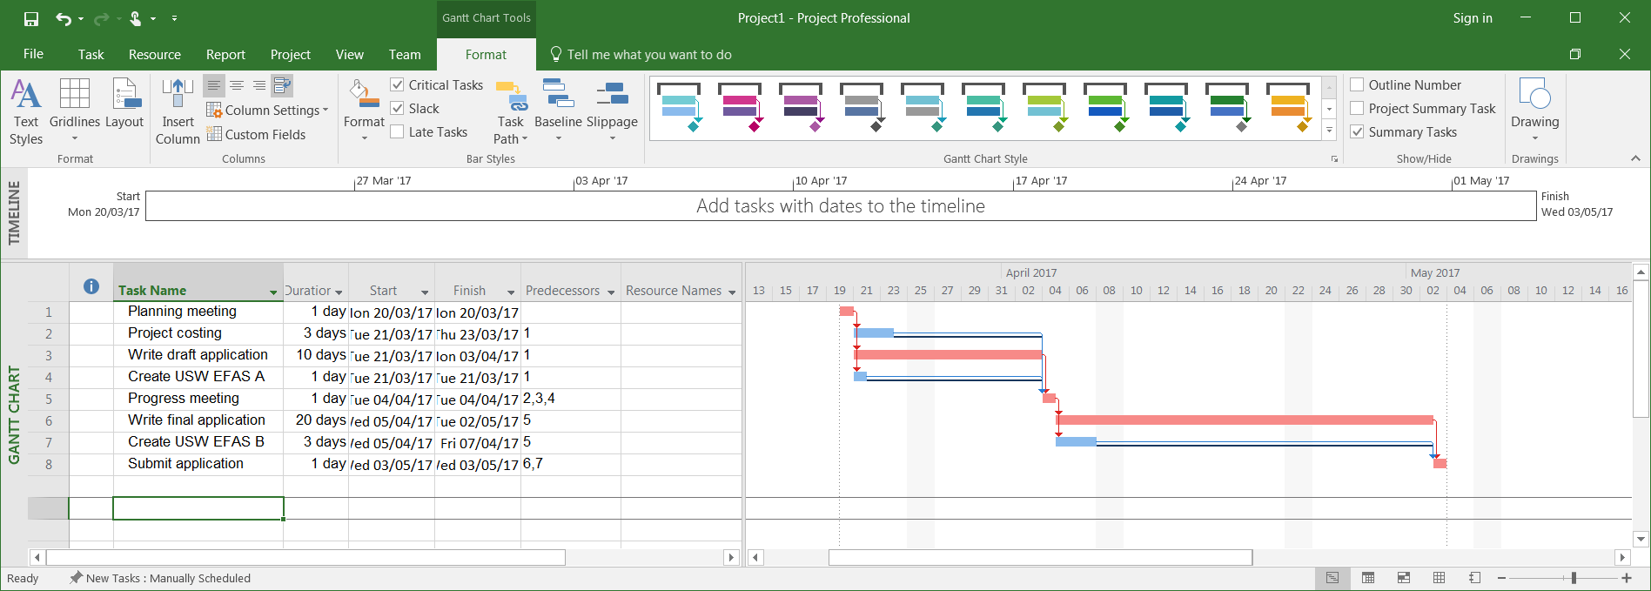

Slack, and other data also be viewed as part of the Task table. This is achieved by adding columns to the table. This is done by right-clicking within the header section of the Task table, selecting Insert Column, and then selecting the data item you want to display. To display Slack, select the Free Slack from the list of attributes:

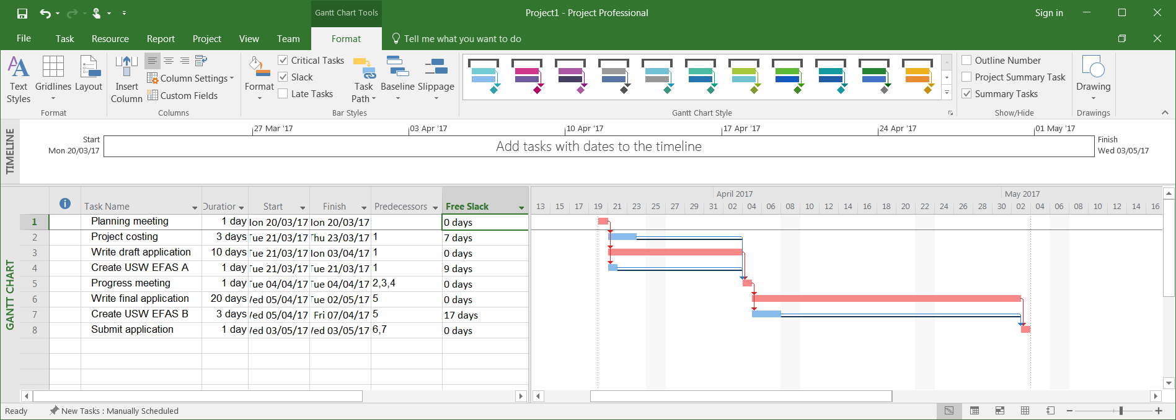

**3. Activity on node**

Another useful way of displaying the critical path is by looking at the Network Diagram view. This view is like the Activity on Node notation used in class. Select the View tab and then click on the Network Diagram button. You will see something like (you might have to zoom out):

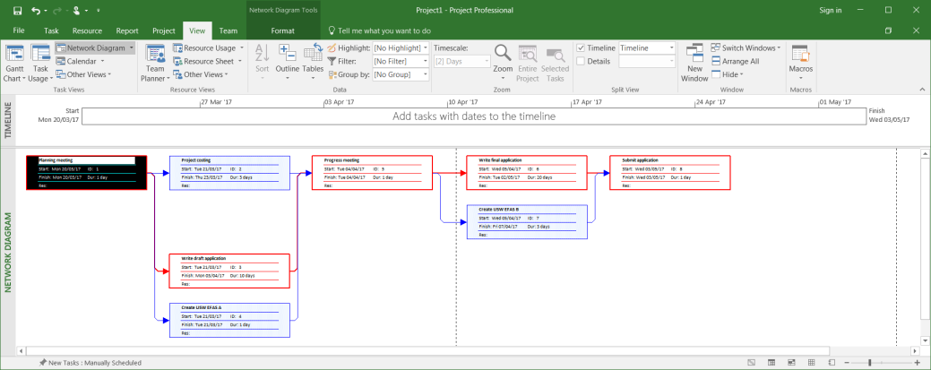

By default, the Network Diagram nodes display the following task data: Name, Start and Finish date, ID, Duration and Resources. It would be useful to format the node to conform to the notation used in class, that is

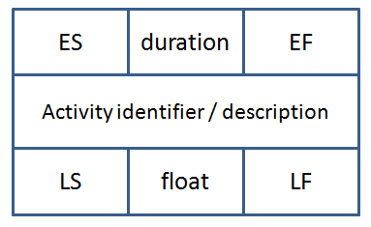

This can be achieved quite easily.

First, right-click anywhere within the white-space surrounding the network diagram.

Select the Box Styles... option from the menu that appears. The Box Styles window appears:

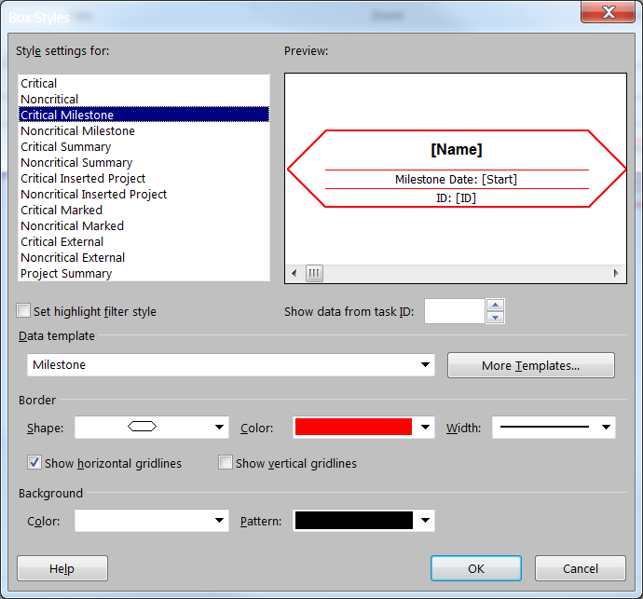

Click the More Templates... button. The Data Templates window appears:

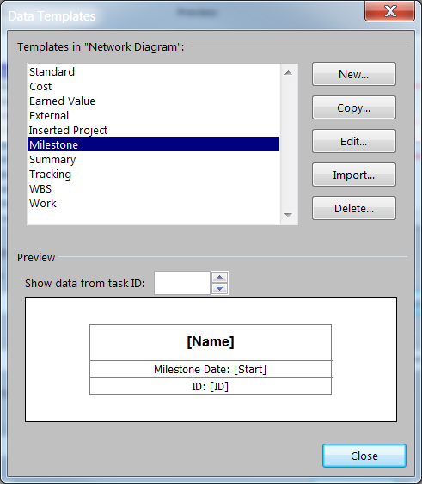

Click the New... button. The Data Template Definition window appears:

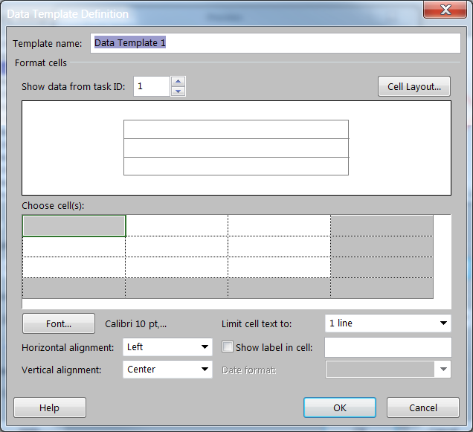

The default name for the new template is Data Template 1. Change this to Activity Box Notation.

The Choose cells grid allows you to select data items to display. Left-click in a cell, activate the drop-down menu (left-click) and select the data item you want displayed in that cell. You should be able to figure out how to produce the cell layout shown below.

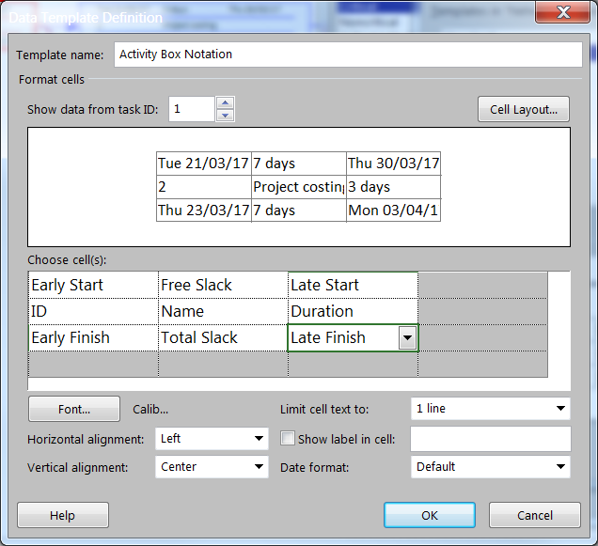

NOTE: The Free Slack field contains the amount of time that a task can be delayed without delaying any successor tasks. If the task has no successors, free slack is the amount of time that a task can be delayed without delaying the entire project's finish date. The Total Slack field contains the amount of time a task's finish date can be delayed without delaying the project's finish date.

When finished, click on OK. You must now tell MS Project to use this new template for the activities displayed in the network diagram. We have 2 types of activity – Critical and Noncritical. Simply select Critical from the Style settings for: list, and then select the new template (Activity Box Notation in this example) from the Data template drop down list:

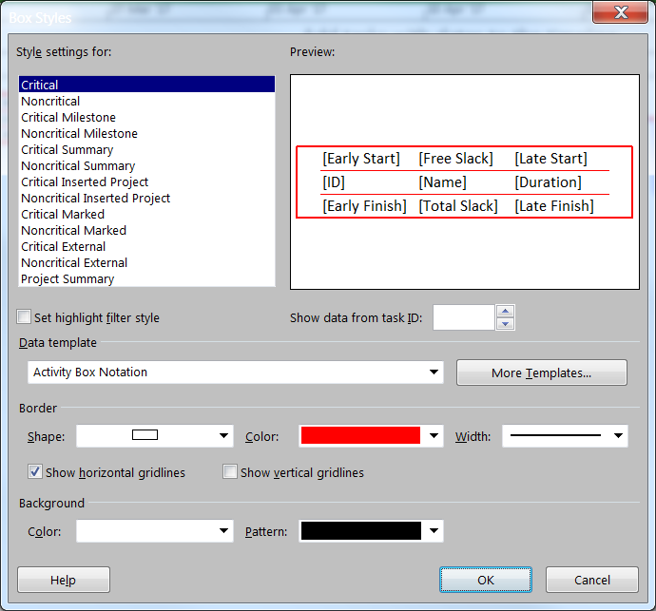

Repeat for Noncritical activities. When done, click on OK. Your network diagram should look something like:

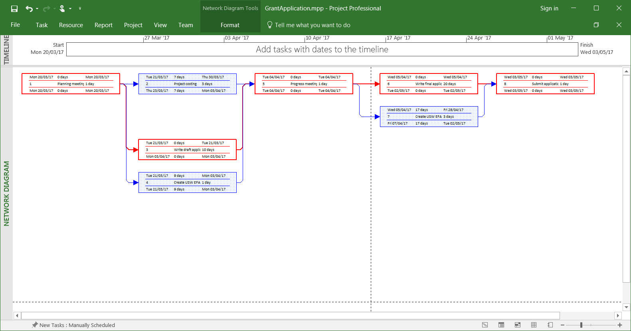

Save your project – you might need to use it again.

**4. Practice**

Display the critical path for the current version of the “SimpleSoftwareProject” – show Gantt Chart and Network Diagram (use the Activity Box notation described in part 3 of this tutorial) views:

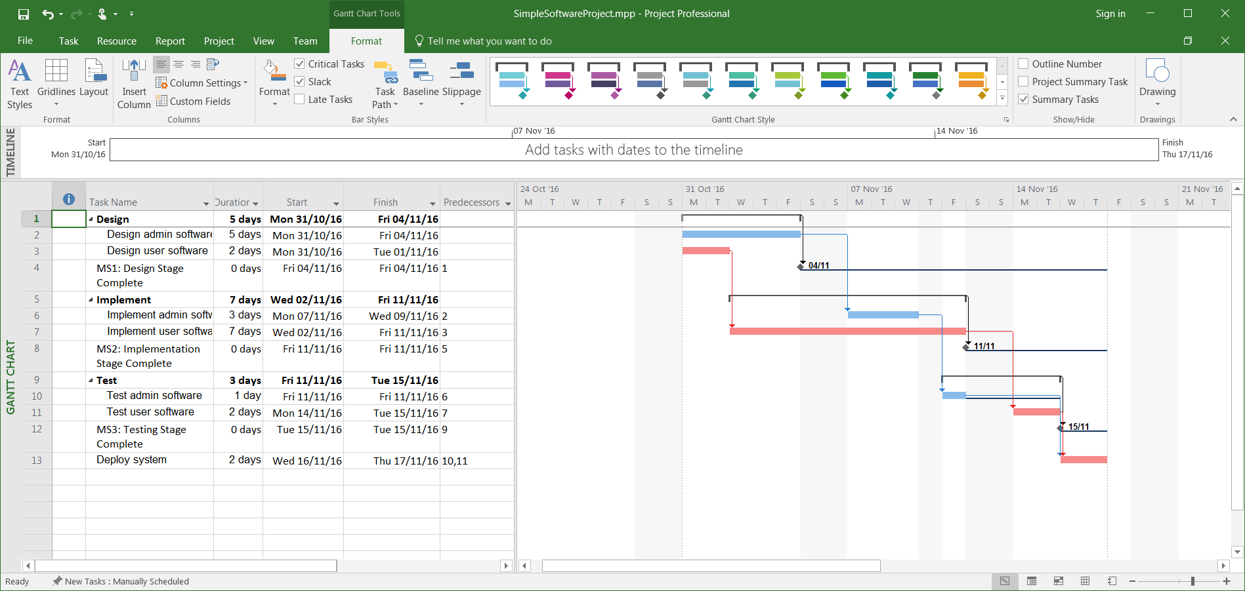

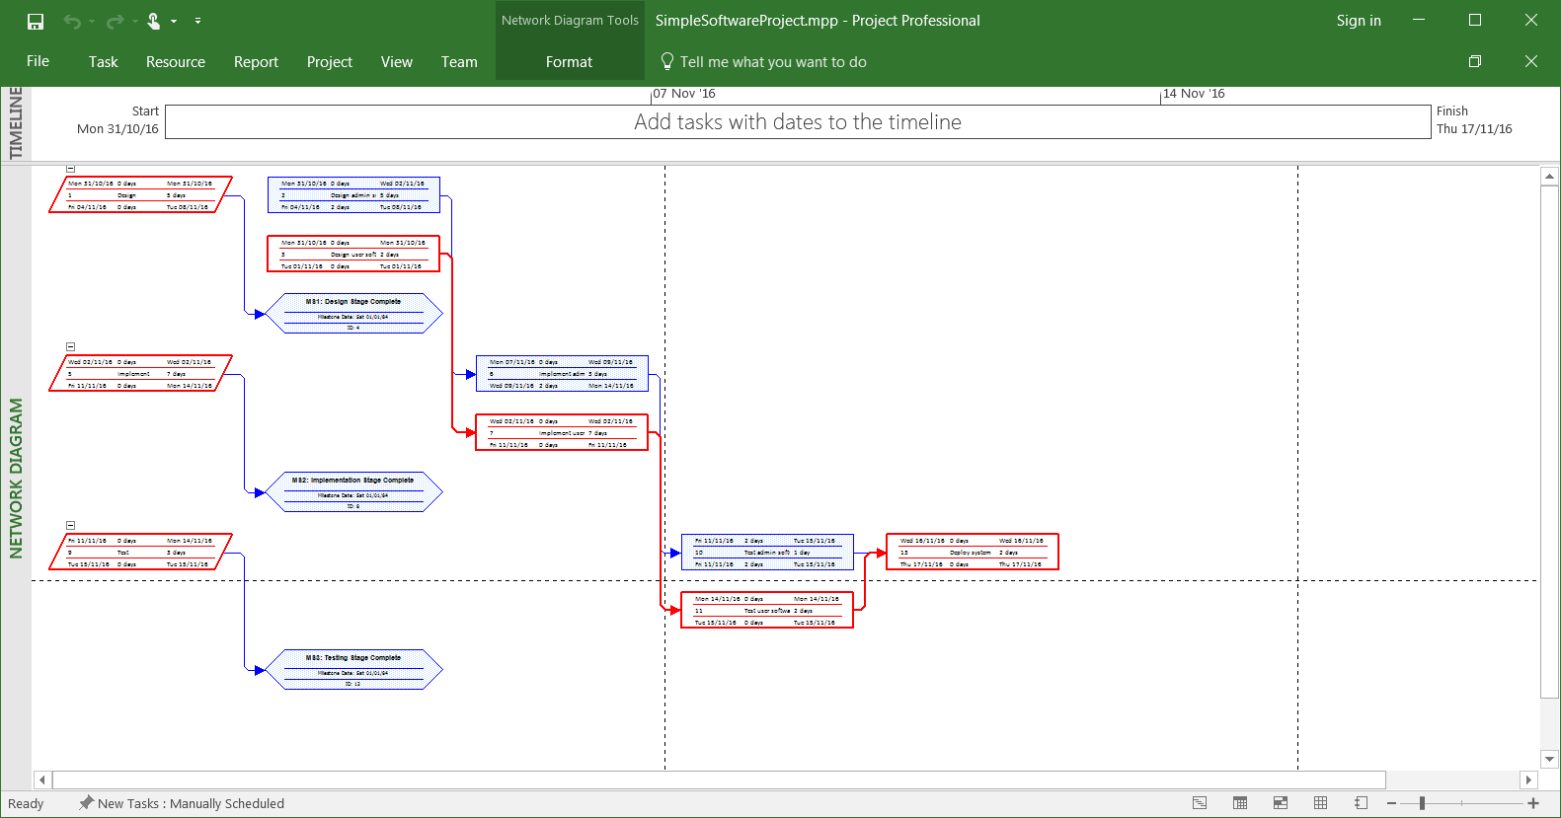

Now do the same for the “BuildRestaurant” project:

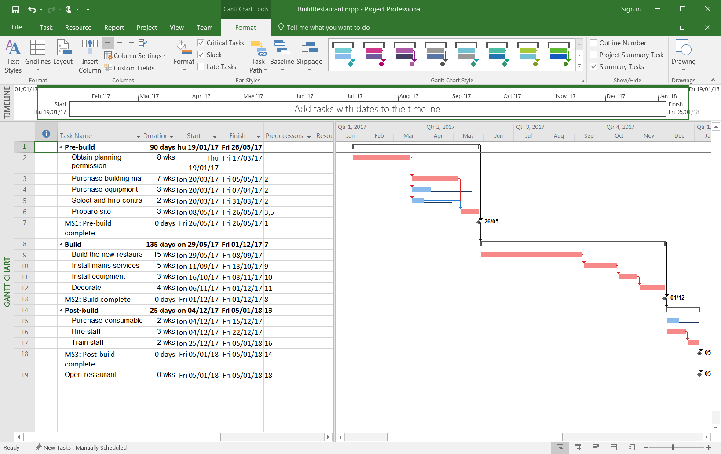

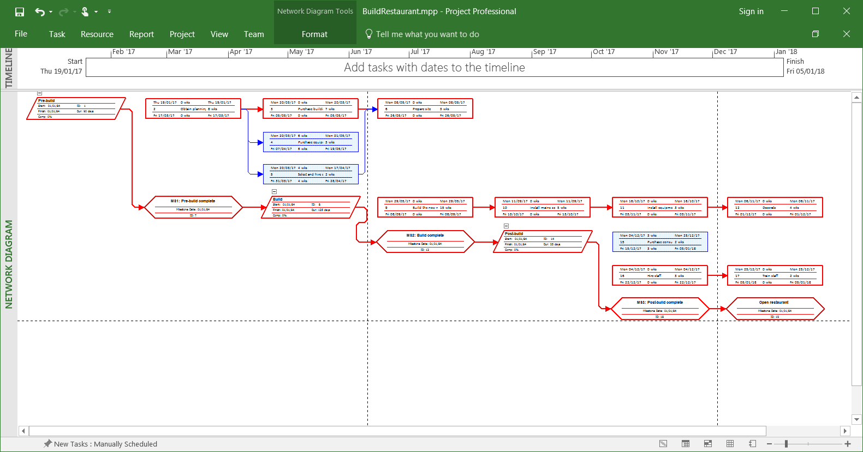

Notice that due to the inclusion of summary tasks and milestone, these diagrams look significantly different to the ones covered in our lectures. The differences will be discussed in class.